CD Assignment 3

--------------------------------

Name: Yash Oswal

Div: B Roll no.: 38

SRN: 201901226

--------------------------------

Input:

kwd void main int float printf

int a = 5; a = a + 2; printf(a);

Output:

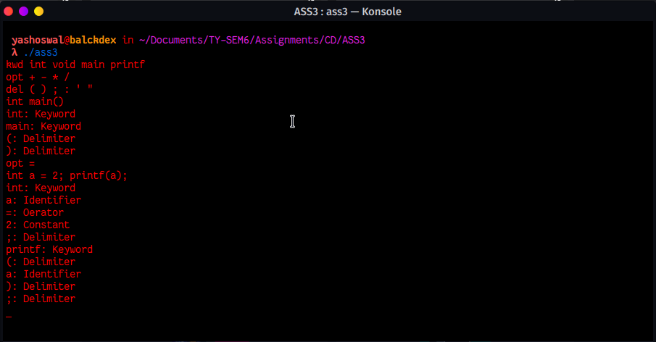

Source Code:

%{

enum {

LOOKUP =0, /* default - looking rather than defining. */

KWD,

IDE,

OPT,

DEL

};

int state;

int add_word(int type, char *word);

int lookup_word(char *word);

%}

%%

\n { state = LOOKUP; }

^kwd { state = KWD; }

^ide { state = IDE; }

^opt { state = OPT; }

^del { state = DEL; }

[0-9] { printf("%s: Constant\n", yytext); }

[+-/*=%] {

if(state != LOOKUP) {

add_word(state, yytext);

} else {

switch(lookup_word(yytext)) {

case OPT:

printf("%s: Oerator\n", yytext);

break;

default:

printf("%s: Identifier\n", yytext);

break;

}

}

}

[;'")(:] {

if(state != LOOKUP) {

add_word(state, yytext);

} else {

switch(lookup_word(yytext)) {

case DEL:

printf("%s: Delimiter\n", yytext);

break;

default:

printf("%s: Identifier\n", yytext);

break;

}

}

}

[a-zA-Z]+ {

if(state != LOOKUP) {

add_word(state, yytext);

} else {

switch(lookup_word(yytext)) {

case KWD:

printf("%s: Keyword\n", yytext);

break;

case IDE:

printf("%s: Identifier\n", yytext);

break;

default:

printf("%s: Identifier\n", yytext);

break;

}

}

}

. /* ignore anything else */ ;

%%

int main()

{

yylex();

}

struct word {

char *word_name;

int word_type;

struct word *next;

};

struct word *word_list;

extern void *malloc() ;

int add_word(int type, char *word)

{

struct word *wp;

if(lookup_word(word) != LOOKUP)

{

printf("!!! warning: word %s already defined \n", word);

return 0;

}

wp = (struct word *) malloc(sizeof(struct word));

wp->next = word_list;

wp->word_name = (char *) malloc(strlen(word)+1);

strcpy(wp->word_name, word);

wp->word_type = type;

word_list = wp;

return 1;

}

int lookup_word(char *word)

{

struct word *wp = word_list;

for(; wp; wp = wp->next) {

if(strcmp(wp->word_name, word) == 0)

return wp->word_type;

}

return LOOKUP;

}